**A Digital Approach to Carbon Footprint Reduction: Tracking and Analytics for a Greener Future**

**Deepali Jadhav**

Vishwakarma Institute of Technology

Pune, India

[deepali.jadhav@vit.edu](mailto:deepali.jadhav@vit.edu)

**Om Suhagir**

Department of IT

Vishwakarma Institute of Technology

Pune, India [om.suhagir24@vit.edu](mailto:om.suhagir24@vit.edu)

**Srushti Mane**

Department of IT

Vishwakarma Institute of Technology

Pune, India [srushti.mane24@vit.edu](mailto:srushti.mane24@vit.edu)

**Anchit Chedge**

Department of IT

Vishwakarma Institute of Technology

Pune, India [anchit.chedge24@vit.edu](mailto:anchit.chedge24@vit.edu)

**Hana Khan**

Department of IT

Vishwakarma Institute of Technology

Pune, India [hana.khan24@vit.edu](mailto:hana.khan24@vit.edu)

**Rutuja Kulkarni**

Department of IT

Vishwakarma Institute of Technology

Pune, India [rutuja.kulkarni24@vit.edu](mailto:rutuja.kulkarni24@vit.edu)

**Abstract:** Snake bites are becoming a significant threat to public health, especially in rural and tropical areas. The current systems cannot classify a snake accurately based on symptoms given for antidote provision. Many of them result in delayed treatment, contributing to death. To overcome this issue, the BiteSage (Snake Bite Antidote Suggester): A Data Science and Machine Learning - based System, which classifies a snake as being venomous or non- venomous based on the symptoms given by the user and gives the user the right antidote. Furthermore, to assist users in formulating symptoms, and therefore real-time counseling advice, a chatbot interface is integrated. The system also provides visualization tools to view information regarding the worldwide trends of snake bites. The model's high precision in classifying bites as venomous and, thus correct antidote recommendations with results supported by comprehensive data analytics. This research aims to assist not only medical professionals in remote places but public also gets educated and prepares itself, thereby saving lives.

**Keywords**: - Machine Learning, Data Science, Antidote Recommendation, Data Visualization, Symptom-based Classification.

# INTRODUCTION

Climate change is a pressing global challenge, with carbon emissions being a primary driver of environmental degradation. The need for accurate measurement and reduction of carbon footprints has become crucial in various sectors, including households, industries, and transportation [1][2]. Several studies highlight the significance of assessing carbon footprints using advanced tools and methodologies such as Life Cycle Assessment (LCA) and Input-Output Analysis (IOA) [3][4]. Additionally, decentralized carbon footprint analysis has been explored to implement targeted mitigation strategies, especially in high-emission regions [7]. Research on product-level carbon footprint comparisons also emphasizes the importance of standardization in measurement techniques [8].

In response to this growing concern, Carbo Track is developed as an Android application that enables users to calculate, monitor, and reduce their carbon footprint based on daily activities. Unlike conventional assessment models, which focus on large-scale industrial or economic activities [5], Carbo Track offers a user-centric approach to sustainability. The application incorporates real-time carbon calculations, dynamic input sliders, and threshold-based feedback mechanisms to enhance user engagement. Furthermore, it employs an appreciation system that encourages users to adopt eco-friendly habits by rewarding those who maintain a low carbon footprint.

Existing research emphasizes the importance of technology-driven solutions in environmental sustainability. Studies have shown that open-source carbon footprint assessment tools can effectively aid in emission reduction strategies [6]. Additionally, research on household carbon footprint measurement demonstrates that individual behavioral changes can significantly impact global carbon reduction efforts [7]. Further studies suggest that lifestyle changes, including shifts in mobility, diet, and energy consumption, play a crucial role in reducing personal carbon footprints [12]. Moreover, low-carbon lifestyle models provide actionable insights into achieving sustainable living beyond decarbonization [13]. By integrating these insights, Carbo Track serves as a practical and interactive solution to promote sustainable living.

This paper explores the design, implementation, and impact of Carbo Track in encouraging carbon-conscious behavior. The study evaluates the effectiveness of real-time monitoring and personalized feedback in reducing individual carbon footprints. By leveraging advancements in mobile technology and user engagement strategies, Carbo Track aims to bridge the gap between awareness and action, empowering individuals to make informed decisions for a greener future.

# CONTRIBUTION OF THE SYSTEM.

The system finds enhanced practical solutions with the advanced technology of BiteSage. This allows precise snake identification and antidote suggestions leading to immediate medical intervention, hence reducing complications. Real-time guidance through its chatbot ensures that critical needs of users are met immediately. Data visualization and trend analysis by the system enhance worldwide understanding on the patterns of snake bites, further promoting public awareness and prevention initiatives. By giving top priority to accessibility, therefore focusing on the provision of the gap within the medical infrastructure to well-represent rural and high- risk areas, BiteSage is an indispensable snake bite management and public health tool.

# LITERATURE SURVEY

Mutinda Cleophas Kyama (2022) et al. High light the burden of snake bite envenoming and neglect in rural areas with poor healthcare infrastructure and under-diagnosis and antidote mix-up in snake bites. The system suggests how to use machine learning-based classificatory real-time

identification of venomous snakes in timely identification, making the Snake Bite Antidote Suggester an important system for real-time symptom classification, so rapid and precise identification is extremely important.

Matos and Ignotti [2] observe the spatial distribution of snakebites, especially in Brazil. However, they notice that most cases of snakebites were reported in rural areas. Moreover, Most of the bites were caused by Bothrops species. The risk of snakebites could only be understood from geographical data, as perceived by the authors.

Alshalah et al. [3] highlighted that in the case of the Eastern Mediterranean region, data associated with snakebites and antivenoms are scattered. According to them, snakebite burden cannot be addressed without proper data. This study also supports the tools such as the development of Snake Bite Antidote Suggester, which allows monitoring the number of cases of snakebites and availability of antivenoms in underserved areas through a visualization of data (journal.pntd.0012200).

It is Laura Scheske, Joost Ruitenberg, and Balram Bissumbhar (2015) [4], discussing in the light of the global antivenom supply crisis in low- resource settings. According to them, it is the inadequacy of the current production and distribution systems for antivenoms. The paper focuses on novel approaches to the distribution of antivenoms with the aim of providing real-time antidote recommendations based on symptom analysis.

Gamulin et al.[5] talked about the subtleties of administering antivenoms via various routes, intravenous vs. intramuscular administration. The authors ascertained that a standardized protocol does not exist and that choosing the route of administration alone puts the patient at the mercy of the outcome of that treatment. Therefore, when prescribing antidotes, the best possible treatment approaches should be taken into account-this study's case.

Asawale (2018) [6]. found the prescribing pattern and rational use of anti-snake venom serum (ASVS). They pointed to an obvious problem of over-prescription and violations of the norms of the World Health Organization guidelines; according to their opinion, a more differentiated treatment strategy can make optimum use of ASVS

Khalid Inamdar et al (2017) [7] analyzed snake bites in the interest of review for ASVS application, risk factors, and contribution to poorer outcomes. They noted early treatment and indicated that treatment initiated after more than six hours post-encounter increased mortality. The study provides a pointer to the need for the prompt diagnosis and that this could be made easier by the immediate identification through

Tools like the Snake Bite Antidote Suggester, which helps with immediate treatment.

Alves-Nunes et al (2024) [8] discussed their research concerning the defensive behavior of Bothrops jararaca and interaction between factors and environment in cases of snakebites. From their findings, the results show that outcomes of resistance of bites might be influenced by factors such as body size, temperature, and heat.

A discussing the perceptions and experiences of emergency physicians in regard to the antivenom use in the treatment of snakebites, Tupetz et al. (2022) [9] highlighted the cost-related access barriers and the variability in treating such cases, especially in cases of non-life-threatening events such as copperhead bites. Absence of clear guidelines and uncertainty about the effectiveness of the antivenoms are considered a major challenge.

Describing the Random Forest algorithm in great detail, within its context of application to classification problems, Cutler et al (2011) [10]. reveal that it can also be applied in regression problems. The paper documents the construction of Random Forests through the method of bootstrapped decision trees and random selection, hence being a powerful tool in applying to a large dataset and performing complex predictions.

According to literature, snakebite envenoming poses a significant burden, with a poor health infrastructure in rural settings and the difficulty of making accurate diagnoses and accessing antivenom. Based on the notion of machine learning algorithms, there are proposed systems, like the Snake Bite Antidote Suggester. These systems will help identify venomous snakes promptly and hasten and precisely treat them. In reality, several studies found evidence of their existence as there is a demand for better epidemiological data, better antivenom administration protocols, and more issues with the supply chain.

# PROPOSED SYSTEM

System consists of three modules:

* 1. Data Classification of Snakes
     + Classifies the snake species in venomous and non-venomous type as well as identify snakes by the type of venom viz. hemotoxic, cytotoxic, neurotoxic etc.
  2. Antidote Suggester
     + Suggest the antidote and give some information to the about the snake to the user according to the symptoms entered by the user.
  3. Chatbot
     + A chatbot that guides the user about the snake bite, its antidote and snake species. Some of the architecture diagrams are mentioned below:

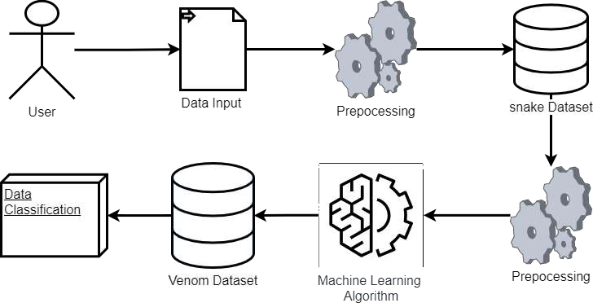

**Fig 1: Data Classification Of Snakes**

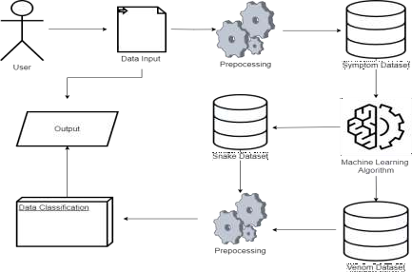

**Fig 2: Antidote Suggestor**

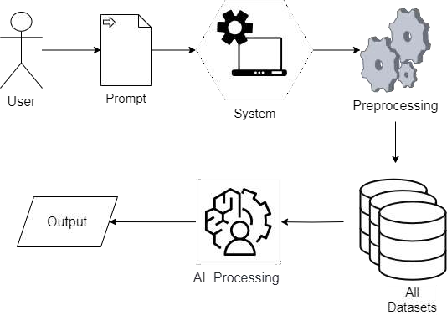

**Fig 3: ChatBot**

In fig 1, there is an architectural diagram of the snake data classification. The module Snake Classification architecture has always been focused on the right output-an answer regarding whether this snake is venomous or not. In doing so, input parameters for which user-entered symptoms are taken, data preprocessing is performed to get proper and clean data that can be analyzed for inspection, and then such preprocessed data is passed to a machine learning algorithm trained with three datasets, namely snakes dataset, venom dataset, and symptom dataset. The algorithm classifies it to be either venomous or non- venomous based on the available data. Using this classification module, other subsequent modules such as the Antidote Suggestor use such an output as their basis thus introducing quick, accurate treatment recommendations. The module stands as the core part of the overall system because there must be a foundation classification to give time for decision-making during snakebites emergencies.

In fig 2, there is an architectural diagram of the Antidote suggester. Figure depicts the design of the Antidote Suggester module, and it emphasizes the suggestion of antidotes through classification of symptoms due to snakebites. The system commences with the entry of symptoms made by the user. These symptoms are preprocessed so as to guarantee data cleaning and formatting prior to undergoing analysis. For purposes of cross- referencing and data enrichment, the system utilizes various datasets such as the snake dataset

and venom dataset. The processed data is analyzed to classify the snake as venomous or non- venomous by a machine learning algorithm. Based

on the classification, the antidote advisor accesses the antidote dataset to determine the best treatment. This recommendation is accordingly output of the system to help users or medical professionals ensure timely administration of the right antidote in preventing potential life and snakebite complication.

In fig 3, the architecture of the Chatbot module includes the role of the system in which it acts as a real-time AI assistant, which delivers critical information and even guides regarding snakebites, starting from the user's input by engaging the chatbot with his/her queries regarding symptoms, or any snake species, or even antidotes-the kind of input, which the robust chatbot engine would then process and analyze based on the natural language processing applied to understand the user's question. The chatbot retrieves relevant information from these datasets, which include the symptom, snake, and antidote datasets, to convey a conversational response to the user. These responses may contain answers, advice, or recommendations about first aid, snake classification, or administration of an antidote.

This module is very helpful for the users in snake prone areas for lifesaving guidance and improvement of public awareness about snakebites

1. **ALGORITHM**
   1. Importing the required libraries numpy, pandas, sklearn, etc.
   2. Load dataset

dataset = Load("path_to_dataset")

* 1. Explore and preprocess the data

1. Check for missing values

If missing_values_exist(dataset):

Handle missing values by imputation or removal, for example.

1. Encode categorical variables

IF categorical_columns_exist(dataset):

Encode using techniques like one-hot encoding or label encoding

1. Split dataset into features (X) and labels (y)
2. (Optional) Tuning the model
   1. Define parameter grid param_grid=

DefineParameters("model_name")

* 1. Cross validation with grid search best_model = GridSearchCV(model,

param_grid).fit(X_train, y_train) Output best_model parameters

1. Saving the trained model Save(model, "model_path")
2. Using the model for predictions on new data new_data = Load("new_data_path") predictions = model.predict(new_data)
3. End

X = dataset.features y = dataset.labels

1. Normalize/Scale features (if needed)

X = Normalize(X) // Example: Min-Max scaling or Standardization

* 1. Split data into training and testing sets X_train, X_test, y_train, y_test = Split(X, y,

test_size=0.2)

* 1. Choose a machine learning model

model = SelectModel("model_name") // Example: LogisticRegression, RandomForest, etc.

* 1. Train the model model.fit(X_train, y_train)
  2. Evaluate the model

1. Predict on test set

y_pred = model.predict(X_test)

1. Calculate the performance metrics accuracy = Accuracy(y_test, y_pred) precision = Precision(y_test, y_pred) recall = Recall(y_test, y_pred)

F1_score = F1Score(y_test, y_pred) Output performance metrics

1. **RESULT AND DISCUSSIONS**

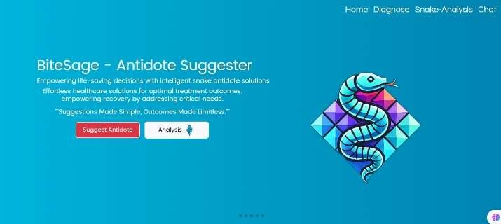

**Fig 4: Home Page**

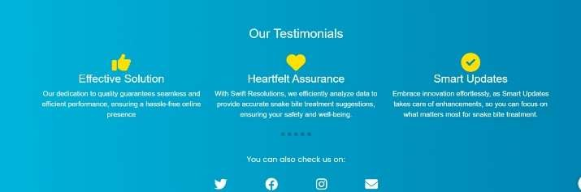

**Fig 5. Testimonials**

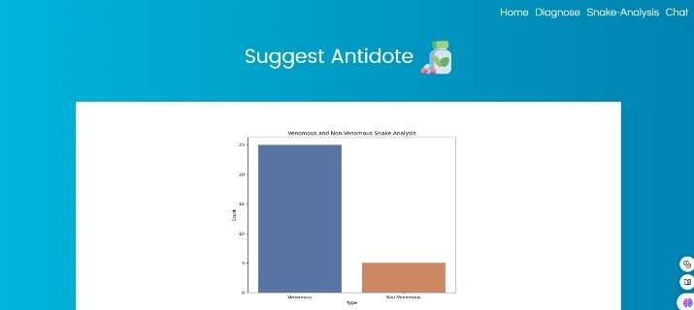

**Fig 6. Classification Of Snakes**

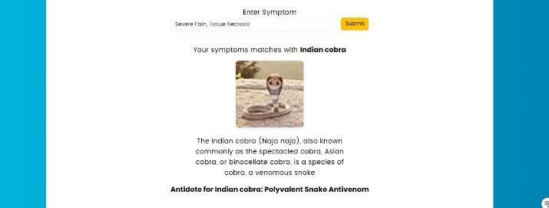

**Fig 7: Antidote Suggester Page**



**Fig 8: Visualization of previous bite cases across the globe.**

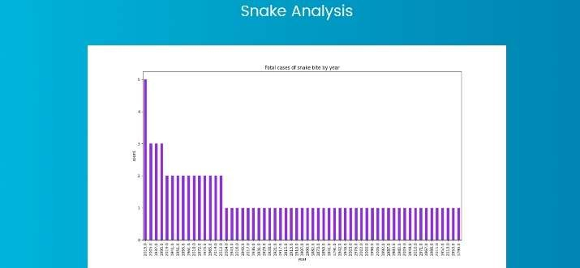

**Fig 9: Snake Bite Analysis Page.**

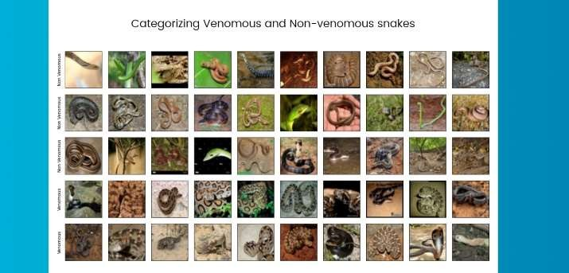

**Fig 10: Snake Analysis Page.**

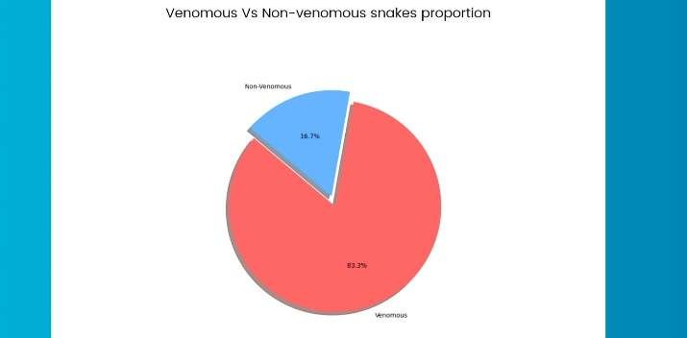

**Fig 11: Graphical Visualization of Snake Species.**

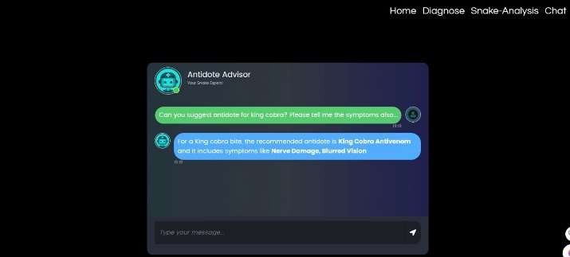

**Fig 12: Chatbot Implementation**

In Fig 4 and 5, the home page of the "BiteSage - Antidote Suggester" offers solution that provides antidotes for snakebites. A Snake icon is given with a small text in which the platform is to empower life-saving decisions through intelligent solutions. "Testimonials" is placed to give an idea of the effectiveness, reliability, and commitment towards updates. Social media icons at the bottom represent contact details and how to get in touch with the team.

In Figure 6, 7 and 8, the Antidote Suggester Page is a diagnostic page to identify species of snakes and provide knowledge about antivenoms associated with them. The interface provides options of diagnosing snake bites by entering symptoms, which returns a probable snake species with an image and description. It also provides an antidote specific to the type of snake. These will include a pictorial representation of the distribution of snake bites associated with the mentioned species, probably on an international map.

In Fig 9, 10 and 11, the Snake Analysis Page analyzes snake data particularly on fatal snake bite cases and snake categorization. The first chart will portray the fatal cases of snake bites over years. The second portion involves categorizing different species of snakes into poisonous and nonpoisonous. Images of both types will be added to enable people to identify them easily. The last chart is a pie chart, which describes the ratio of venomous snakes against non-venomous ones; it reflects that among 100 snakes, 83.3% are venomous and 16.7% are nonvenomous. It gives information about how many dangerous species exist and which species they are.

In Fig 12, there is the chat interface of an "Antidote Advisor" chatbot, which appears as part of a snakebite diagnosis and analysis system at the Chatbot page [Fig 16]. The user's query to this interface is: "What is the antidote for and symptoms from a King Cobra bite?" For example, chatbot suggests "King Cobra Antivenom" as the antidote and lists symptoms such as "Nerve Damage" and "Blurred Vision."

Comparison of the proposed system and other existing systems with respect to their accuracy, the graphical representation is given below:

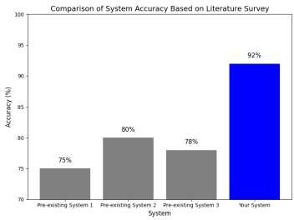

**Fig 13: Comparison of system accuracy based on Literature survey**

This chart represents a comparison of accuracy levels between three pre-existing systems and the newly developed system, focusing on diagnosing and recommending antidotes for snake bites. The existing systems exhibit accuracy rates of 75%, 80%, and 78%, respectively. In contrast, the newly developed system demonstrates a significantly higher accuracy rate of 92%. This improvement highlights the system's enhanced reliability and effectiveness in delivering accurate antidote recommendations, suggesting that it may be a more effective solution for managing snakebite cases, especially in critical or resource-limited situations.

# CONCLUSION

The BiteSage: Snake Bite Antidote Suggester represents a significant advancement in the management of snakebite envenoming, combining machine learning algorithms, symptom-based classification, and real-time antidote recommendations to enhance the speed and accuracy of snake identification and treatment. By addressing the critical gaps in existing diagnostic and treatment methods, this system has the potential to save lives in regions where snakebites are prevalent and healthcare resources are limited. Moreover, its integration of data visualization tools provides valuable insights into global snakebite trends, further aiding public health efforts. In future, expanding the system's database to include more snake species and integrating real-time geographical data can enhance its effectiveness and adaptability in various environments.

# REFERENCES

1. E. Z. Manson, J. K. Gikunju, and M. C. Kyama, "Diagnostic and antivenom immunotherapeutic approaches in the management of snakebites," 2022. Available: source.
2. R. R. Matos and E. Ignotti, "Incidence of venomous snakebite accidents by snake species in Brazilian biomes," 2020. Available: source.
3. A. Alshalah, D. J. Williams, and A. Ferrario, "From fangs to antidotes: A scoping review on snakebite burden, species, and antivenoms in the Eastern Mediterranean region," 2024. Available: source.
4. L. Scheske, J. Ruitenberg, and B. Bissumbhar, "Needs and availability of snake antivenoms: Relevance and application of international guidelines," 2015. Available: source.
5. E. Gamulin, S. M. Lukačević, B. Halassy, and

T. Kurtović, "Snake antivenoms—Toward better understanding of the administration route," 2023. Available: source.

1. M. C. Mehta, and P. S. Uike, "Drug utilization analysis of anti-snake venom at a tertiary care center in central Maharashtra: A 3-year retrospective study," Asian J. Pharm. Clin. Res., vol. 11, no. 8, pp. 134-137, 2018.
2. K. Inamdar, S. M. Parhate and R. D. Randad, "Pharmacotherapeutic study of efficacy, safety, and prognostic analysis of anti-snake venom serum in snake bite patients," Int. J. Basic Clin. Pharmacol., vol. 6, no. 4, pp. 906-912, 2017
3. J. M. Alves-Nunes, A. Fellone, S. M. Almeida-Santos, C. R. de Medeiros, I. Sazima, and

O. A. V. Marques, "Study of defensive behavior of a venomous snake as a new approach to understand snakebite," Sci. Rep., vol. 14, no. 10230, 2024

1. A. Tupetz, L. K. Barcenas, A. J. Phillips, J. R.

N. Vissoci, and C. J. Gerardo, "BITES: A Qualitative Analysis Among Emergency Medicine Physicians on Snake Envenomation Management Practices," Toxicon, vol. 202, pp. 12-19, 2022.

1. A. Cutler, D. R. Cutler, and J. R. Stevens, "Random Forests," in Machine Learning and Data Mining, New York: Springer, 2011, pp. 157-175.
2. Anonymous, "Introduction to AI Chatbots," International Journal of Engineering Research & Technology (IJERT), vol. 9, no. 7, pp. 223-229,

2020.

**Datasets:**

Antidote Dataset Snake Dataset Symptom Dataset